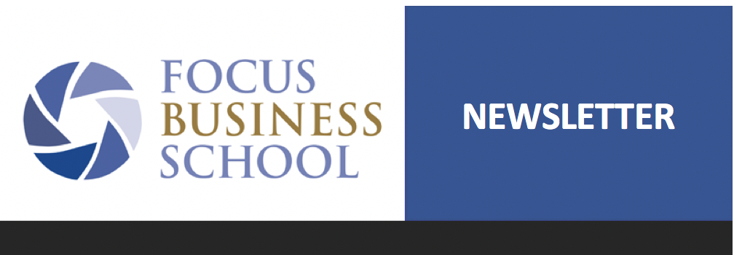

Dear missions friends!

What an eventful first week of May it has been for Focus Business School! We have had four days of introduction and training in Brazil, an introductory trip to Botswana and South Africa, teacher training in Sri Lanka with an organization that helps sex trade victims as well as training for 25 high school teachers in government schools in Mocambique!

Brazil
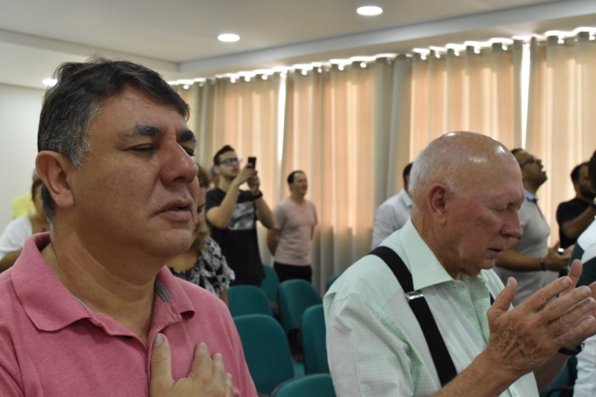
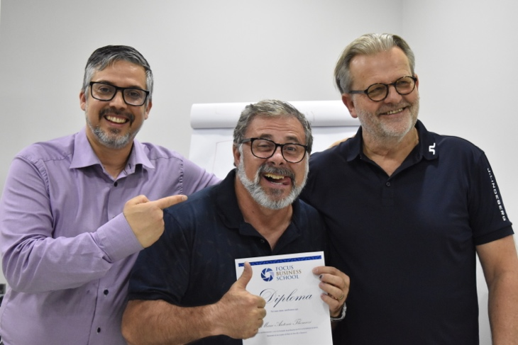
A door has been opened for us through God’s special leading. Giannis, one of the leaders of FBS in Greece, met a man from Brazil, Marco, at the ICCC conference in Israel as 2018 came to a close.
Before Marco came to the conference he had been praying for a new tool to bring back to his country in order to help business people. With God’s leading Giannis and Marco got in touch and as Giannis share about FBS both of them experienced the Holy Spirit’s presence very strongly and wept.

They were both convinced that God wanted to take FBS to Brazil. After this meeting they called me and I felt that this was a door that the Lord was about to open and hence we started planning for a trip to Brazil to introduce FBS there.
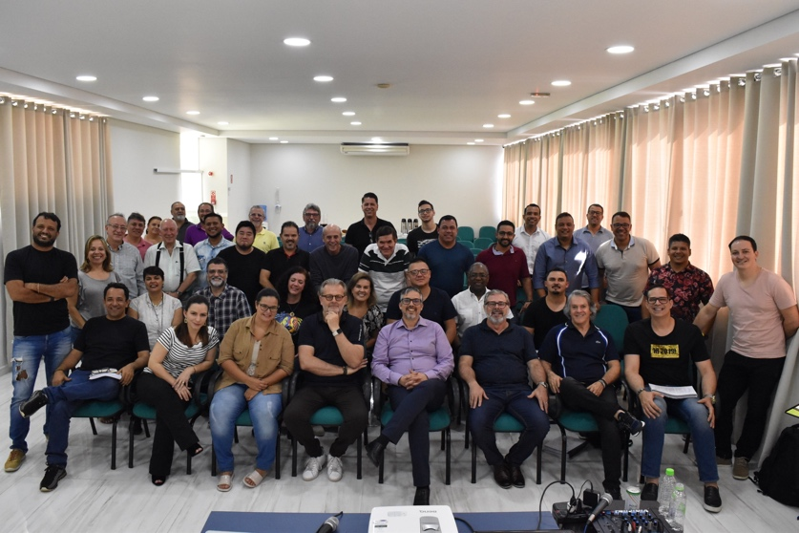
We weren’t sure whether anyone at all would show up for the training, since nobody apart from Marco knew what FBS was. He sent out an invitation and hoped that we would at least see 20 people come. To our great surprise more than 40 people showed up. Some had travelled 1000km by plane, others by car. Pastors with thousands of members were present together with successful business owners and professors.
After getting off to a slow start the message was accepted with open arms and devoted hearts! We all felt that God has a special plan for Brazil for such a time as this and that FBS can play a role in this new phase.
Please check out my greeting from Brazil here (Swedish): https://www.youtube.com/watch?v=iqlmDYcRfoc&t=1s

South Africa
Thomas Jonsson just got back from a trip to South Africa and Botswana. In Cape Town he met at pastor who had previously attended one of our ToTs (Training of trainers) in Johannesburg and who had now taken over a big church in one of the world’s biggest slums, Khayelitsha (400,000 people). The pastor wanted to start FBS in the area to help lift people out of poverty. Khayelitsha is the 4th largest slum in the world.
In Botswana Thomas met a group of savvy, young entrepreneurs with a passion for helping young men and women who have graduated from university to become entrepreneurs. They were all fired up about FBS and wanted us to come there as soon as possible to train their organization.
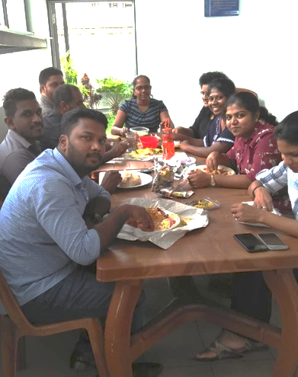
Sri Lanka

The local team in Sri Lanka have trained an organization called LEAD. They help victims of the sex trade to get new lives. We’re thrilled that they want to use our material in their work! Around 20 of their employees were trained and we hope to continue to be of service to them. Another encouraging step for us was the fact that most of the lessons were given by local staff.

Moçambique
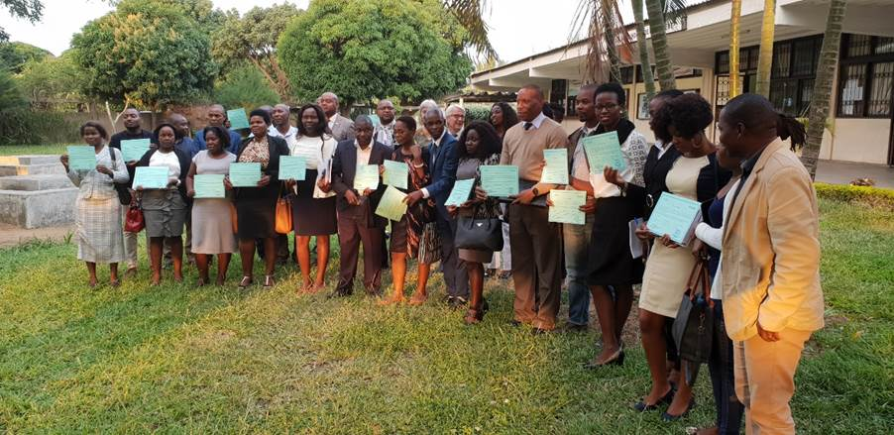
What an exciting opening in this country! The government schools have opened up the possibility of using FBS in the subject entrepreneurship at the high school level, including all verses of Scripture. During the week around 25 high school teachers were trained for this, the demand being that those receiving the training needed to be Bible believing Christians. The training took place in cooperation with the Dept of Education. One of the department directors said that this course is not just about passing examinations but for passing life – both an encouraging and a true word!

