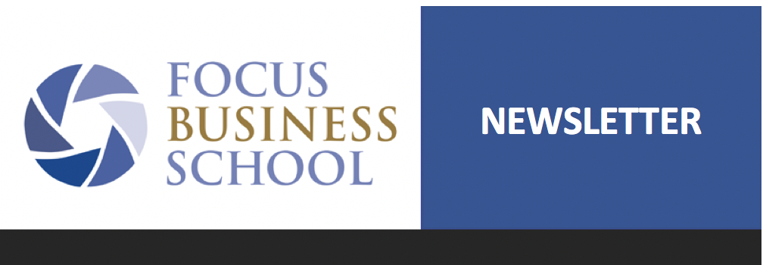
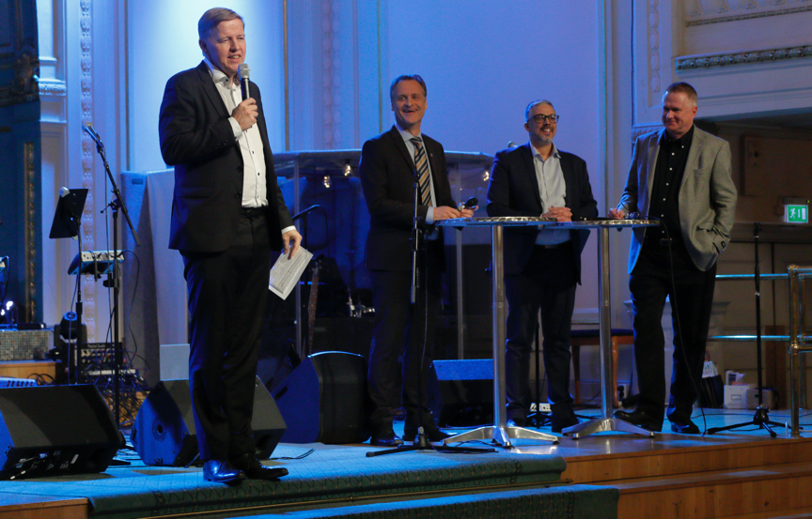

Dear friends!
We were very excited when we gathered on November 20th in Citykyrkan Stockholm to celebrate Focus Business School’s 10-year anniversary (founded November 20th 2009 in Yangon, Myanmar). The atmosphere was friendly and upbeat throughout the evening. We kicked things off with a business leader dinner that had attracted businesspeople and pastors from both Norrköping, Uppsala and Stockholm. There were many new and inspiring connections taking place!
In the evening around 150 people gathered in the main auditorium. The Christian tv channel Vision Sverige had built a studio in one corner and were busy interviewing participants about our work. Per-Olof Eurell and André Andersson were the hosts of the evening.
We were treated to music by Petrus and Jenny Eurell with their band – which featured a high standard, both spiritually and musically!
Anna and I had the opportunity to share our journey so far, from getting on a plane to Myanmar until today. We have been able to see FBS spread to so many countries and experience so many stories of changed lives and we note that the work is just growing in strength. This was a time to remind ourselves of what God has done and what is continuing to do.
Lennart Eriksson from Star of Hope told the audience how he sees FBS and he thought that the main strength of the school is the way that it fights poverty. Also, he encouraged everyone to become a monthly donor.
After that there was a break with coffee and cake, along with lots of chatter and laughter throughout the venue.
This was followed by a panel on the opportunity for Christian businesspeople to help strengthen the role of the church in creating jobs and fighting many of the problems that we struggle with today – e.g. trafficking and poverty. We were delighted to have both the chairman of Business as Mission, Mats Tunehag, as well as Torbjörn Ehrling of the International Christian Chamber of Commerce, present. Both of these global organizations actually have Swedish origins. I think this is one expression of the missionary legacy that Sweden has.
The evening was concluded by words of thanks to everyone who has been part of making FBS into what it is today, and the 20+ pastors who were there led a strong prayer for every participant. We are so happy with the way the evening turned out and we want to say thank you to all of you who were there and also to those of you who couldn’t. You have all supported in the work over the last 10 years and now we’re looking ahead to what God has in store for the upcoming 10 years!
I’m also pleased to note that we have received a great deal of media attention. The final tally is 2 articles in Världen Idag, one in Dagen, live coverage in Vision Sverige and not least an insert in Dagens Industri that we produced together with Star of Hope (who also celebrated an anniversity, their 50th). 2,400 people tuned in to the live feed on Facebook during the event. Using this link you can watch as well (in Swedish):
https://www.facebook.com/visionsverige/videos/2277669259198817?vh=e&d=n&sfns=mo
The sound quality is poor during the first 16 minutes, after that it’s better.
Wishing you all a Merry Christmas!

Marco and Anna Strömberg

